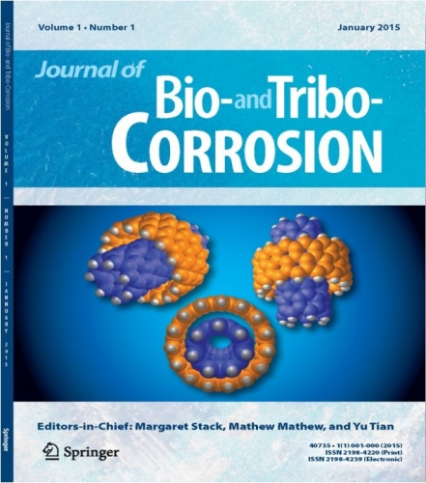

### **Please submit your paper by Friday 26th of February 2016 in order to be considered for publication in the next two issues.**

### **One of the benefits of submitting your paper to us is that, on acceptance, it will be published online immediately.**

* **If you have any enquiries regarding your submissions and the journal please contact the Publishing Editor at** [**Marta.Moldvai@springer.com**](mailto:Marta.Moldvai@springer.com) **or the Editor –in-Chief Margaret Stack****, margaret.stack@strath.ac.uk**

#### **Submissions for the next issue:**

[Three-Body Abrasion Corrosion Studies of High-Cr Cast Irons: Benefits and Limitations of Tribo-electrochemical Methods](http://link.springer.com/article/10.1007/s40735-015-0006-z)

Stachowiak G., M. Salasi and G. Stachowiak

[Tribocorrosion Mechanisms of Ti6Al4V in Artificial Saliva by Zero-Resistance Ammetry (ZRA) Technique](http://link.springer.com/article/10.1007/s40735-015-0008-x)

Licausi M. P., A. Igual Muñoz, V. Amigó Borrás and N. Espallargas

[Atmospheric Pressure Plasma Jet Treatment of Human Hair Fibers](http://link.springer.com/article/10.1007/s40735-015-0007-y)

Öngel C., M. Keleş, E. Acar and Ö. Birer

[READ MORE …](http://link.springer.com/journal/40735/1/1/page/1)

* Sliding wear, abrasion (including micro-abrasion), erosion, fretting, and fatigue interactions with corrosion
* Models and mechanistic maps
* Biological processes such as hip and knee joint wear, wear of dental materials, and wear of artificial heart vales
* Renewable technologies, such as wave, wind (including offshore), and tidal power
* Conventional energy, including nuclear, oil and gas, and combined cycle coal conversion
* Lubricants and tribo-corrosion interactions with lubrication, including bio-oils
* Case studies and rapid communications on hot topics

#### [**Sample articles form the 1st issue:**](http://link.springer.com/journal/40735/1/1/page/1)

[**Journal of Bio- and Tribo-Corrosion**](http://www.springer.com/materials/surfaces+interfaces/journal/40735)

### **Publisher: Springer**

### **Editors-in-Chief: M.M. Stack, M.T. Mathew and Y. Tian**

### **2nd Issue Publication Date: June 2015**

The Journal of Bio- and Tribo-Corrosion publishes papers on bio- and tribo-corrosion interactions including, but not exclusively, in dental and orthopaedic applications and in oil and gas, wave, wind, and tidal energy applications. Rigorously reviewed research papers and reviews offer an international perspective.

[**1ST ISSUE IS OUT!**](http://link.springer.com/journal/40735/1/1/page/1)

#### **Specific topics include:**

©2016 - Journal of Bio- and Tribo-Corrosion - Springer

CALL FOR PAPERS!